Bài thực hành 9

Trần Văn Quyền

MSSV: 19574802010166

Câu 1:

import cv2

import matplotlib.pyplot as plt

img = cv2.imread("D:\\Tran Quyen\\quyen.png")

anh_xam = cv2.cvtColor(img, cv2.COLOR_BGR2GRAY)

_, otsu = cv2.threshold(anh_xam, 0, 255, cv2.THRESH_BINARY + cv2.THRESH_OTSU)

plt.subplot(131), plt.imshow(cv2.cvtColor(img, cv2.COLOR_BGR2RGB))

plt.subplot(132), plt.imshow(cv2.cvtColor(anh_xam, cv2.COLOR_BGR2RGB))

plt.subplot(133), plt.imshow(cv2.cvtColor(otsu, cv2.COLOR_BGR2RGB))

plt.show()

cv2.waitKey(0)

cv2.destroyAllWindows()

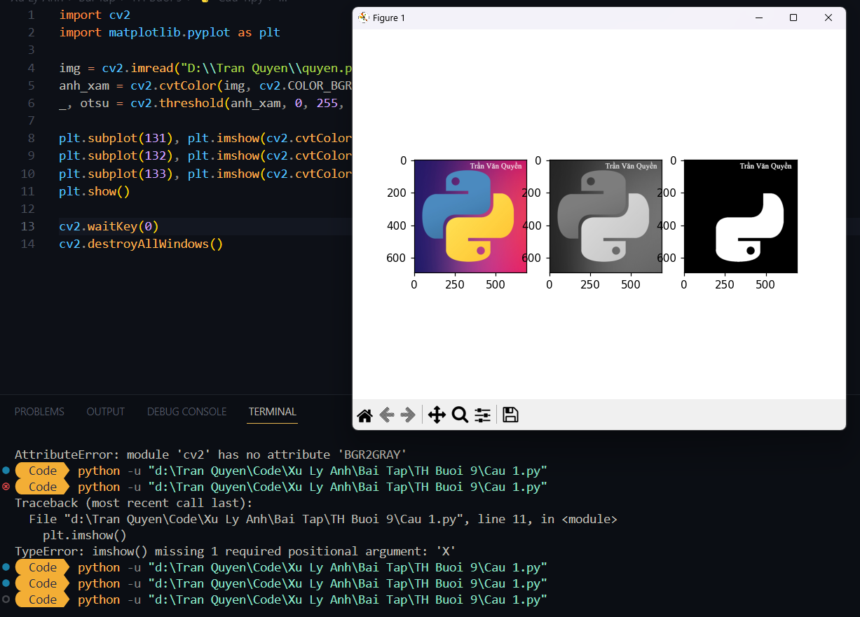

Câu 2:

import cv2

import numpy as np

img = cv2.imread("D:\\Tran Quyen\\quyen.png")

pts1 = np.float32([[317,9],[667,6],[330,59],[667,65]])

pts2 = np.float32([[0,0],[300,0],[0,300],[300,300]])

M = cv2.getPerspectiveTransform(pts1, pts2)

dst = cv2.warpPerspective(img, M, (300,300))

cv2.imshow("Phoi canh", dst)

cv2.waitKey(0)

cv2.destroyAllWindows()

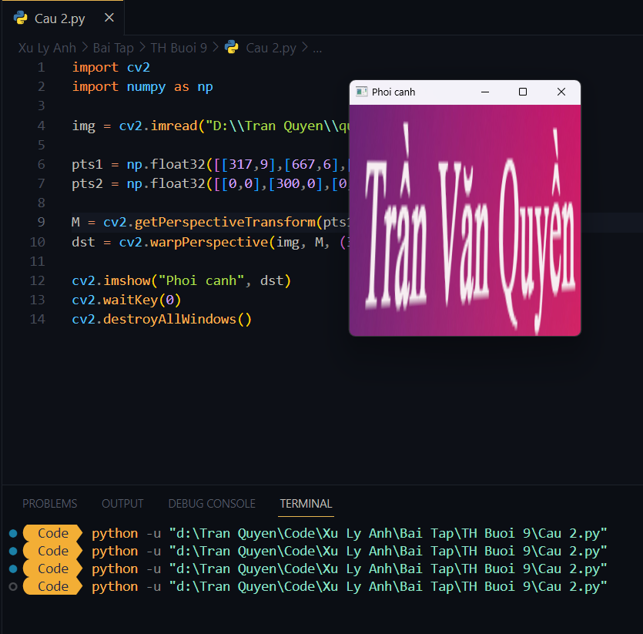

Câu 3:

import cv2

img = cv2.imread("D:\\Tran Quyen\\quyen.png")

x = 0

def get_x(pos):

global x

x = pos

cv2.namedWindow("Canny")

cv2.createTrackbar('Nguong duoi','Canny',0,100,get_x)

while True:

anh_xam = cv2.cvtColor(img, cv2.COLOR_BGR2GRAY)

canny = cv2.Canny(anh_xam, x, 2*x)

cv2.imshow("Canny", canny)

if cv2.waitKey(1) == ord('q'):

break

cv2.destroyAllWindows()

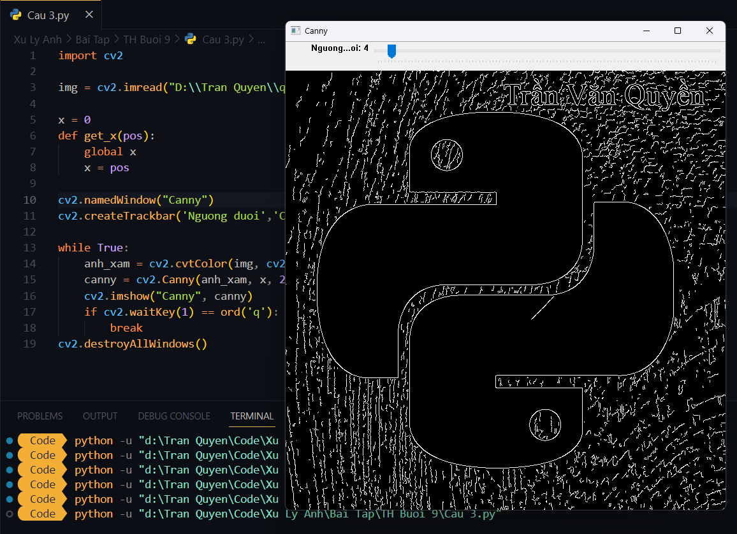

Câu 4:

import cv2

img = cv2.imread("D:\\Tran Quyen\\quyen.png")

(h,w) = img.shape[:2]

goc = 0

def get_goc(x):

global goc

goc = x

cv2.namedWindow("Xoay")

cv2.createTrackbar('Goc','Xoay',0,360,get_goc)

while True:

M = cv2.getRotationMatrix2D((w/2,h/2), goc, 1)

ro = cv2.warpAffine(img, M,(w,h))

cv2.imshow("Xoay", ro)

if cv2.waitKey(1) == ord('q'):

break

cv2.destroyAllWindows()

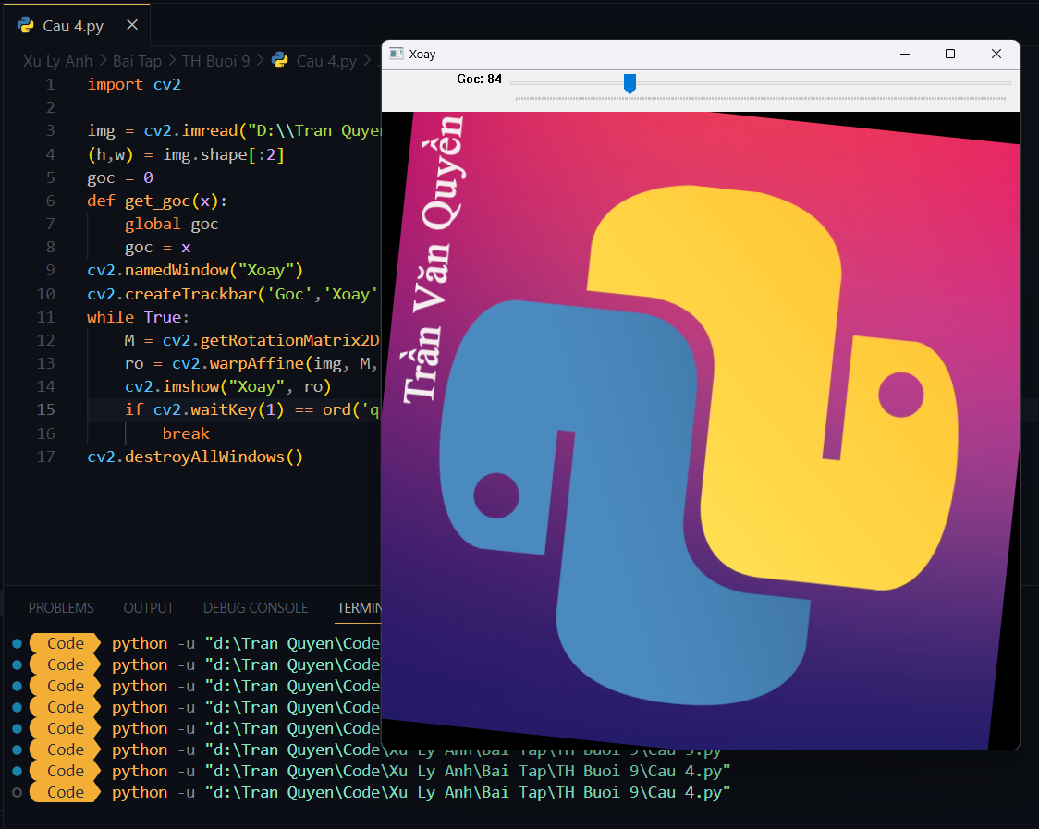

Câu 5:

import cv2

import matplotlib.pyplot as plt

img = cv2.imread('D:\\Tran Quyen\\quyen.png')

anh_xam = cv2.cvtColor(img, cv2.COLOR_BGR2GRAY)

_, thresh = cv2.threshold(anh_xam, 127, 255, cv2.THRESH_BINARY)

kernel = cv2.getStructuringElement(cv2.MORPH_RECT, (5, 5))

erosion = cv2.erode(thresh, kernel, iterations=1)

dilation = cv2.dilate(thresh, kernel, iterations=1

opening = cv2.morphologyEx(thresh, cv2.MORPH_OPEN, kernel)

closing = cv2.morphologyEx(thresh, cv2.MORPH_CLOSE, kernel)

contours, hierarchy = cv2.findContours(thresh, cv2.RETR_TREE, cv2.CHAIN_APPROX_SIMPLE)

img_contour = cv2.drawContours(img.copy(), contours, -1, (0, 255, 0), 2)

plt.subplot(231), plt.imshow(cv2.cvtColor(img, cv2.COLOR_BGR2RGB))

plt.subplot(232), plt.imshow(cv2.cvtColor(erosion, cv2.COLOR_BGR2RGB))

plt.subplot(233), plt.imshow(cv2.cvtColor(dilation, cv2.COLOR_BGR2RGB))

plt.subplot(234), plt.imshow(cv2.cvtColor(opening, cv2.COLOR_BGR2RGB))

plt.subplot(235), plt.imshow(cv2.cvtColor(closing, cv2.COLOR_BGR2RGB))

plt.subplot(236), plt.imshow(cv2.cvtColor(img_contour, cv2.COLOR_BGR2RGB))

plt.show()

